S32K144 EVB User Manual
- Get to know S32K144-EVB.
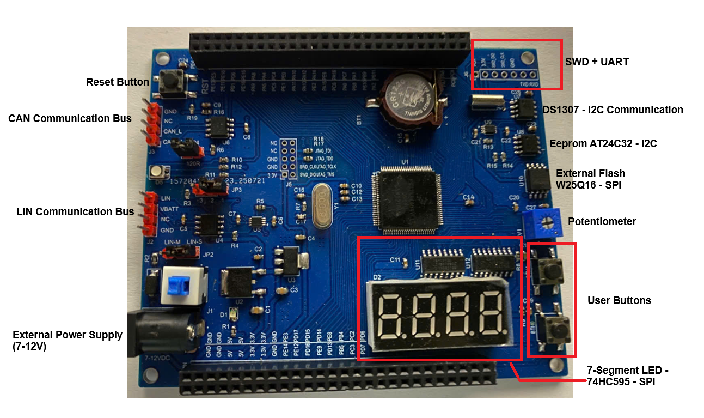
- S32K144 EVB Features:
  - Supports S32K144 100LQFP.
  - External Crystal 8MHz.
  - Easy access to the MCU I/O header pins for prototyping.
  - On-chip connectivity for CAN, LIN, UART, I2C.
  - CAN TJA1051T/3 and LIN TJA1027.
  - Potentiometer for precise voltage and analog measurement.
  - RGB LED.
  - Two push-button switches (BTN0 and BTN1).
  - DS1307 and AT24C32 for I2C communication practice.
  - External flash W25Q16 for SPI communication practice.
  - LED 7-Segment with 74HC595 for SPI communication practice.
  - External 7-12V via jack DC 5.5x2.1

- Jumper Settings
Jumper | Configuration | Description
JP2 | LIN-M: For Lin Master  LIN-S: For Lin Slave | Select LIN communication role Master or Slave
JP3 | 1-2: LIN SLP driver by GPIO Pin.  2-3: LIN SLP Connect to 5V-DC | Select LIN SLP connection
JP4 | Short: Enable CAN 120R resistor | Enable/Disable CAN 120R resistor

- GPIO Mapping
Component | S32K144
LED RGB RED | PTD15 (FTM0 CH0)
LED RGB BLUE | PTD0(FTM0 CH2)
LED RGB GREEN | PTD16(FTM0 CH1)
Potentiometer | PTA6 (ADC0_SE2)
BTN0 | PTC12
BTN1 | PTC13
CAN TX | PTE5(CAN0_TX)
CAN RX | PTE4 (CAN0_RX)
LIN TX | PTD7(LPUART2_TX)
LIN RX | PTD6 (LPUART2_RX)
DS1307/AT24C32 I2C SDA | PTA2 (LPI2C0_SDA)
DS1307/AT24C32 I2C SCL | PTA3 (LPI2C0_SCL)
74HC595 SER | PTC1 (LSPI2_SOUT)
74HC595 SRCLK | PTC15 (LSPI2_SCK)
74HC595 RCLK | PTC14 (LSPI2_PCS0)
W25Q16 DI | PTB4 (LSPI0_SOUT)
W25Q16 DO | PTB3 (LSPI0_SIN)
W25Q16 SCK | PTB2 (LSPI0_SCK)
W25Q16 CS | PTB0 (LSPI0_PCS0)
Jump J6 TXD Pin | PTC7 (LPUART1_TXD)
Jump J6 RXD Pin | PTC6 (LPUART1_RXD)

- Component Schematic.
- CAN Communication.
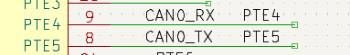
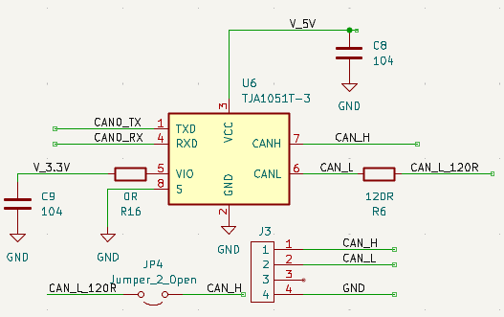

- LIN Communication.
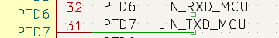
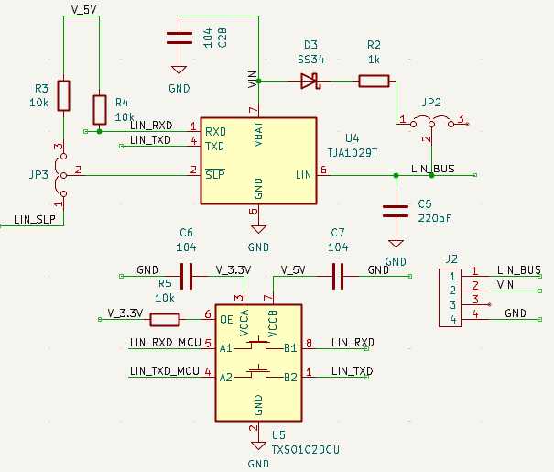
- LED RGB.

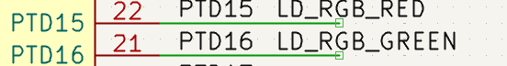
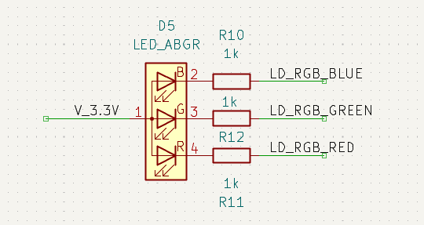

- User Button.
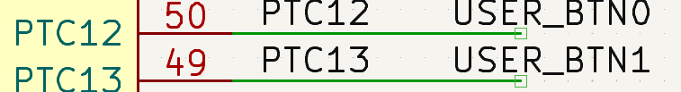
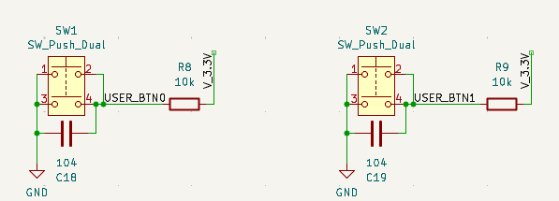
- Potentiometer.
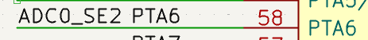
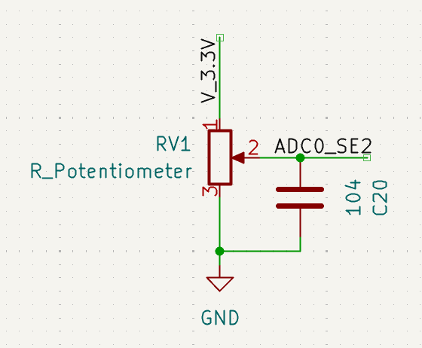

- DS1307/AT24C32.
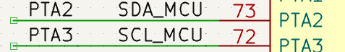
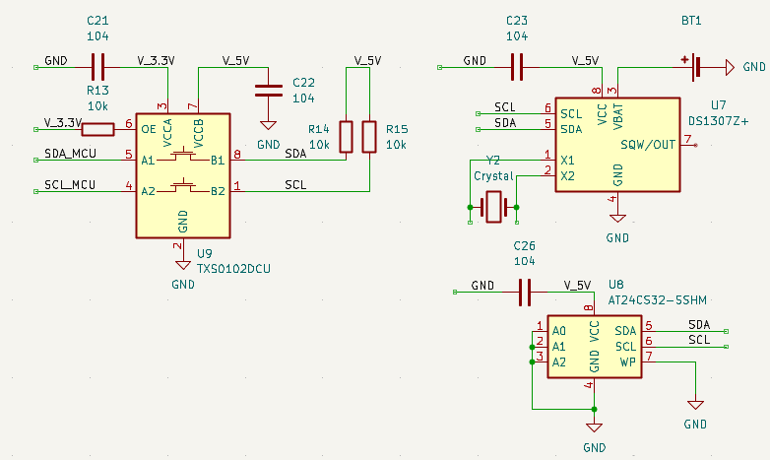

- External Flash W25Q16.
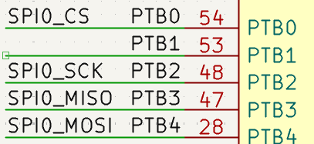
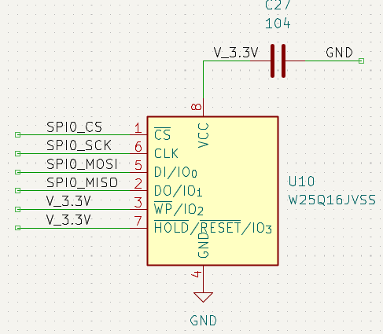
- LED 7-Segment 74HC595.
